**Main Template**

**Ordered set**

**Interactive and Receive**

**Print __int128**

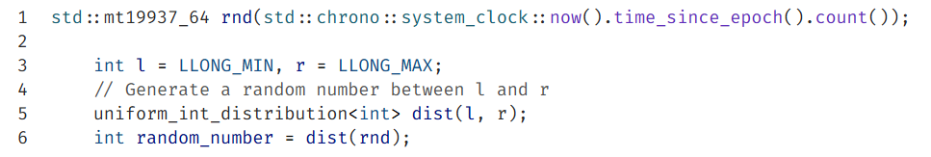**Random**